PROFILE
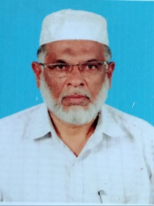
1. Name: S.MOHAMED IBRAHIM .

2. Date of Birth: 03-05-1960

3. Address:

Residential: Office:

30/9B 2nd Street, Professor of Arabic, Nehru Nagar, Jamal Mohamed College, Kajamalai, Trichy-620020.
Trichy-620023. Mobile: 9150681288
Email: drmijmc@gmail.com

4. Designation: ASSOCIATE PROFESSOR.

5. Educational Qualifications:

Examination Passed Year

M.A 1980

M.Phil 1989

Ph.D 2010

6. Experience: Under Graduate: 27 Years Post Graduate : 24 Years M.Phil : 7 Year

7. Areas of Specialization:

Modern Arabic Prose, Poetry, Arabic Grammar, Comparative Grammar, Literary

History of Arabic, Arabic & English Translation.

8. Languages Known: Arabic, English, Tamil and Urdu.

9. Subjects Taught:

Under Graduate: Prose, Poetry, Grammar and Islamic History. Post Graduate: Modern Prose, Islamic Philosophy, Grammar, M.Phil: Research Methodology, Literary History
10. Research Supervision:

MPhil.Degree:- Completed: Pursuing: 2

14. Details of Seminars Organised: 1

15. Details of Orientation /Refresher Courses attended.
Orientation Course: 1 , Refresher Courses: 3

16. Countries Visited: Saudi Arabia.

17. Other Information:

1.Board of Studies –Jamal Mohamed College.

2.Question Setter Board – (i)University of Madras. (ii)The New College.
3.Answer Script Evaluation Board-(i)Jamal Mohamed College. (ii)The New College. (iii)BARD.

